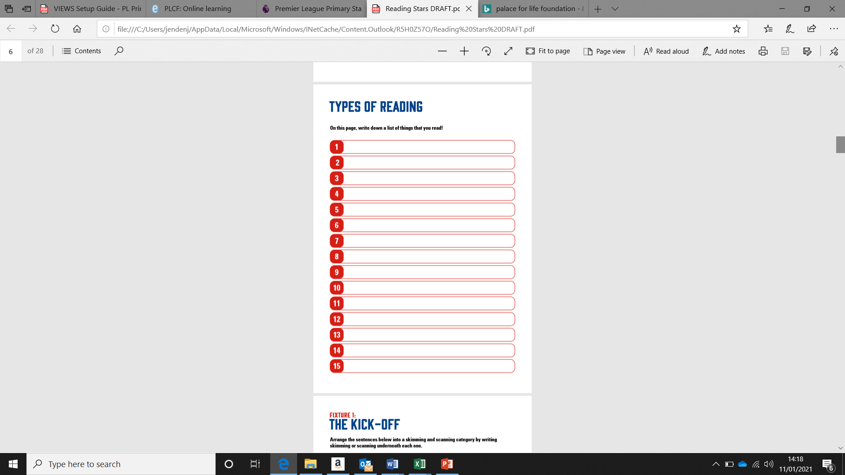

***Labels***

***Instructions***

***Books***