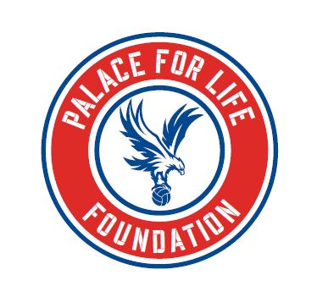
CUSTOMER COMPLAINTS / FEEDBACK

Palace for Life Foundation is committed to providing an excellent service for everyone we work with. We also want to learn from your feedback, to enable us continually improve. Our handling of complaints forms an important part of this approach and the following sets out the framework by which your feedback/complaint will be handled.
All complaints or feedback made by customers, internal and external, will be dealt with in a transparent and professional manner ensuring consistency of approach.
To make a complaint or give feedback to the Foundation on any of their activities or events please use the following methods:
- Phone: 0208 768 6047
- E-mail: admin@palaceforlife.org
- Post: Selhurst Park Stadium, London SE25 6PU

Palace for Life Foundation is committed to investigating all complaints and feedback that is logged within an acceptable time frame of any investigation, but we will endeavour to complete the process as speedily as possible and in all cases no longer than 5 working days.. However we will acknowledge receipt of your feedback or complaint immediately.
In the event that you are not satisfied with how a complaint is handled you have the right to seek further information from a member of our Senior Management Team. Please call the above number to register this issue.

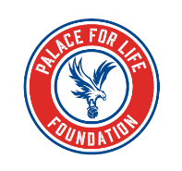
COMPLAINTS & FEEDBACK FORM
DETAILS – PHASE 1
To be completed by any staff member who receives a complaint

Name of complainer/customer |  |  |  |  | Child Ref
Contact details of complainer
Name of logger (staff)
Date of complaint |  | / / | Date of incident | / / |  |  | Venue
Complaint details
(ask relevant questions around events leading up to the issue itself)
Staff members concerned
(Specific names make it easier to address any issues and can speed up the investigation process)
Complaint entered into Incident log? Yes/No (If no please explain why)
Name of Manager to follow up.
MANAGEMENT – PHASE 2
Manager Investigation
(Against relevant complaint details)
Manager findings/feedback/actions to complainer/customer
(including any refund or compensation offered)
Nature of complaint/allegation (please tick below):
Minor issues serious complaint Partner complaint Safety concern
CLOSURE – PHASE 3
To be completed by original logger (staff member)

Complainer/customers satisfaction at action taken
Print Name & Sign
Date the call was made.

