Inclusion Sports Day
Thursday 27th July 2017, 11-2pm
Registration Form

Full Name

Date of Birth & Age

Gender

Ethnicity

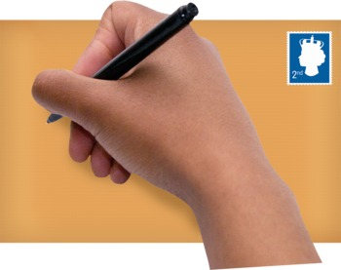
Address
Telephone number

Email address

Photo Consent 
Yes/No
Name & contact number of parent/carer attending for under 16 year olds or those who need 1:1 support
Any Additional Needs

Active (over 30 mins moderately intensive physical activity during past 1 week) or inactive.


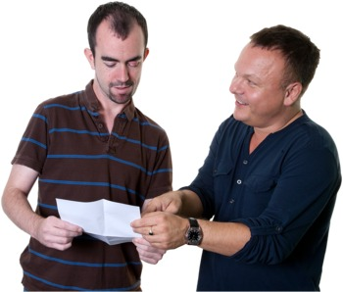
Please return this form to: Michael Harrington, Disability Manager, Palace for Life Foundation,
Selhurst Park, London, SE25 6PU or michaelharrington@palaceforlife.org

